Prof. V. B. Shah Institute of Management,

R. V. Patel College of Commerce (ENG. MED.),

V. L. Shah College of Commerce (GUJ. MED.) &

**Sutex Bank College of Computer Application & Science**

(Accredited ‘B’ (CGPA 2.55) by NAAC Dec.-2009)

Veer Narmad South Gujarat University, Surat



Bachelor of Computer Application

(5th Semester) Year 2025-26

**AIRSTRO**

**Guided By:**

Mrs. Sanskruti Ramani

**Submitted By:**

647 - Nishil Chavda

658 - Deep Sorathiya

678 - Rahul Gadhiya

**INDEX**

|  |  |  |
| --- | --- | --- |
| **NO** | **CONTENT** | **PAGE NO** |
| 1 | Introduction | 2 |
| 2 | Project Profile & Feature | 4 |
| 3 | System Flow Diagram | 8 |
| 4 | DFD/UML Diagram | 10 |
| 5 | ER Diagram | 13 |
| 6 | Database Dictionary | 14 |
| 7 | System Design | 18 |
| 8 | Conclusion | 23 |
| 9 | Annexures | 25 |

1. **Introduction**
   1. **Overview of The Project**

The **Airstro – Online Flight Booking System** is a web-based platform developed using **React.js, TailwindCSS, and JavaScript for the frontend, Node.js and Express.js for the backend, and MongoDB as the database**. The system allows users to register and log in to search for available flights, book flight tickets, view their bookings, and cancel them if required. The **Admin** can manage and update flight details, such as scheduling, rescheduling, cancellation, and pricing through full CRUD operations. The project supports **two main roles: Admin and User**, ensuring secure authentication and separate dashboards for each. Additionally, making online flight reservation faster and more user-friendly.

* 1. **Overview of The System**
* To digitize the complete flight booking and management process.
* To provide secure login and role-based access for Admin and User.
* To allow administrators to manage flights through add, update, schedule, and cancel operations.
* To enable users to search available flights, book tickets, and cancel bookings.
* To provide users access to view booking history and ticket details.
* To improve accuracy, transparency, and efficiency in the online flight reservation process.
  1. **Problem Statement**

In traditional flight booking, passengers often need to visit travel agencies or airline counters physically to check flight availability and purchase tickets. This process is time-consuming, inconvenient, and lacks transparency in pricing and schedule updates. Manual management of flight schedules makes it difficult for administrators to update flight information, which may lead to booking errors and miscommunication. Users cannot easily track their booking history or cancel tickets without lengthy procedures. There is no centralized system to manage flight details, user records, and booking data, which may result in data duplication, loss, or mismanagement. To overcome these issues, we developed a digital **Online Flight Booking System – Airstro**.

1. **Project Profile & Feature**
   1. **Project Profile**

|  |  |
| --- | --- |
| **Project** **Title** | **Airstro** |
| **Frontend** | **React.js, TailwindCSS** |
| **Backend** | **Node.js, Express.js** |
| **Database** | **MongoDB** |
| **Browser** | **Chrome, FIREFOX, SAFARI** |
| **Platform** | **VS Code, MongoDB Compass** |
| **Internal Guide** | **Mrs. Sanskruti Ramani** |
| **Submitted To** | **Mrs. Sanskruti Ramani** |

* 1. **Features of Admin/User**

**Admin Panel**

* Login is required using admin email and password.
* Admin can add new flights, update flight details, or delete flights.
* Admin can view all flights available in the system.
* Admin can view all user bookings along with passenger details.
* Admin can update booking status or delete bookings if necessary.
* Admin dashboard provides a centralized flight & booking management interface.

**User Panel**

* Users can Register/Login using email and password for authentication.
* Main navigation includes: Home, Deals & Offers, My Trips, About Us, Login, Signup
* Home Page displays Hero section, booking widget, offers, and recommended destinations.
* About Page describes Airstro’s mission and international network along with loyalty benefits.
* Flight Search Page allows users to search for flights based on:
  + From / To
  + One-Way / Round-Trip
  + Travel Date(s)
  + Number of Passengers
  + Class Type (Economy / Business)
* Flight Results Page shows available flights with:
  + Filters (airlines, stops, time slots)
  + Sorting (price, duration, time)
  + Expandable details & price comparison
* Users can select a flight and complete the booking instantly.
* My Trips Page displays:
  + All booked flights
  + Total fare
  + Booking status
  + Users can cancel flights anytime
* Users cannot book or manage flights without logging in.
  1. **Directory Structure**

**AIRSTRO/**

**|**

**|── backend/**

**| |── config/**

**| |── controllers/**

**| |── middleware/**

**| |── models/**

**| |── routes/**

**| |── utils/**

**| |── uploads/**

**| |──.env**

**| |── package.json**

**| └── server.js**

**|**

**|── frontend/**

**| |── public/**

**| |── src/**

**| | |── components/**

**| | |── pages/**

**| | |── services/**

**| | |── context/**

**| | |── assets/**

**| | └── App.jsx**

**| |── package.json**

**| └── vite.config.js**

**|**

**└── README.md**

**3. System Flow Diagram (SFD)**

**Admin Process Flow Diagram**

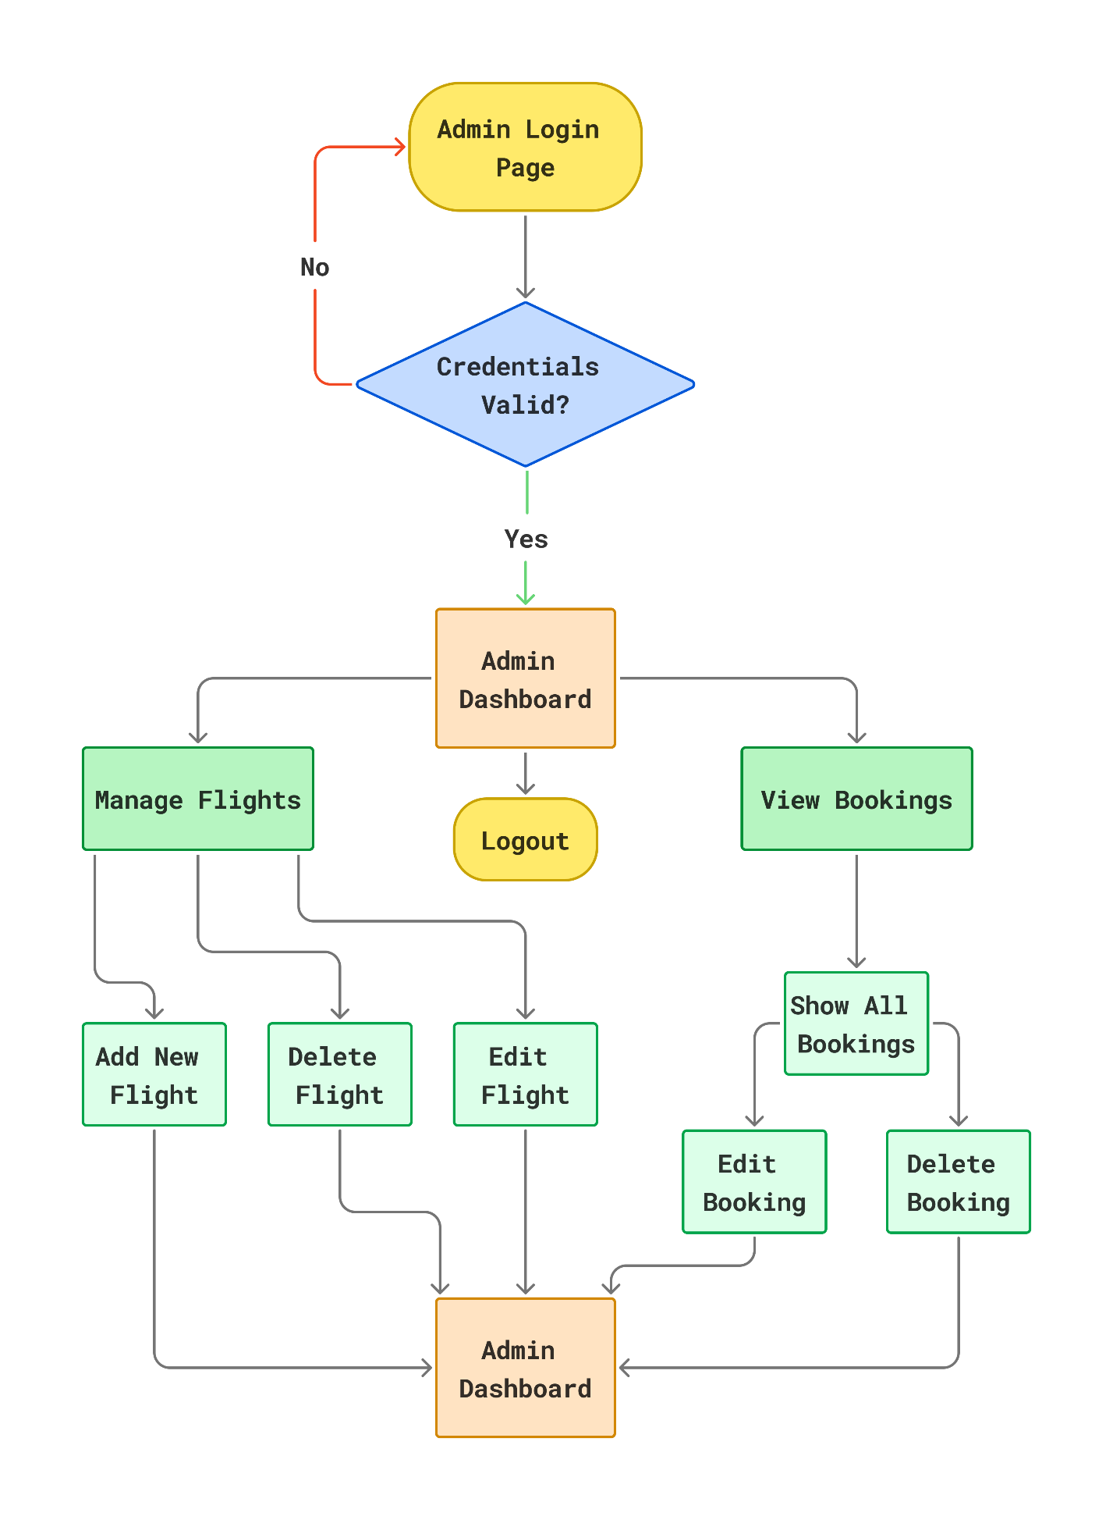

**User Process Flow Diagram**

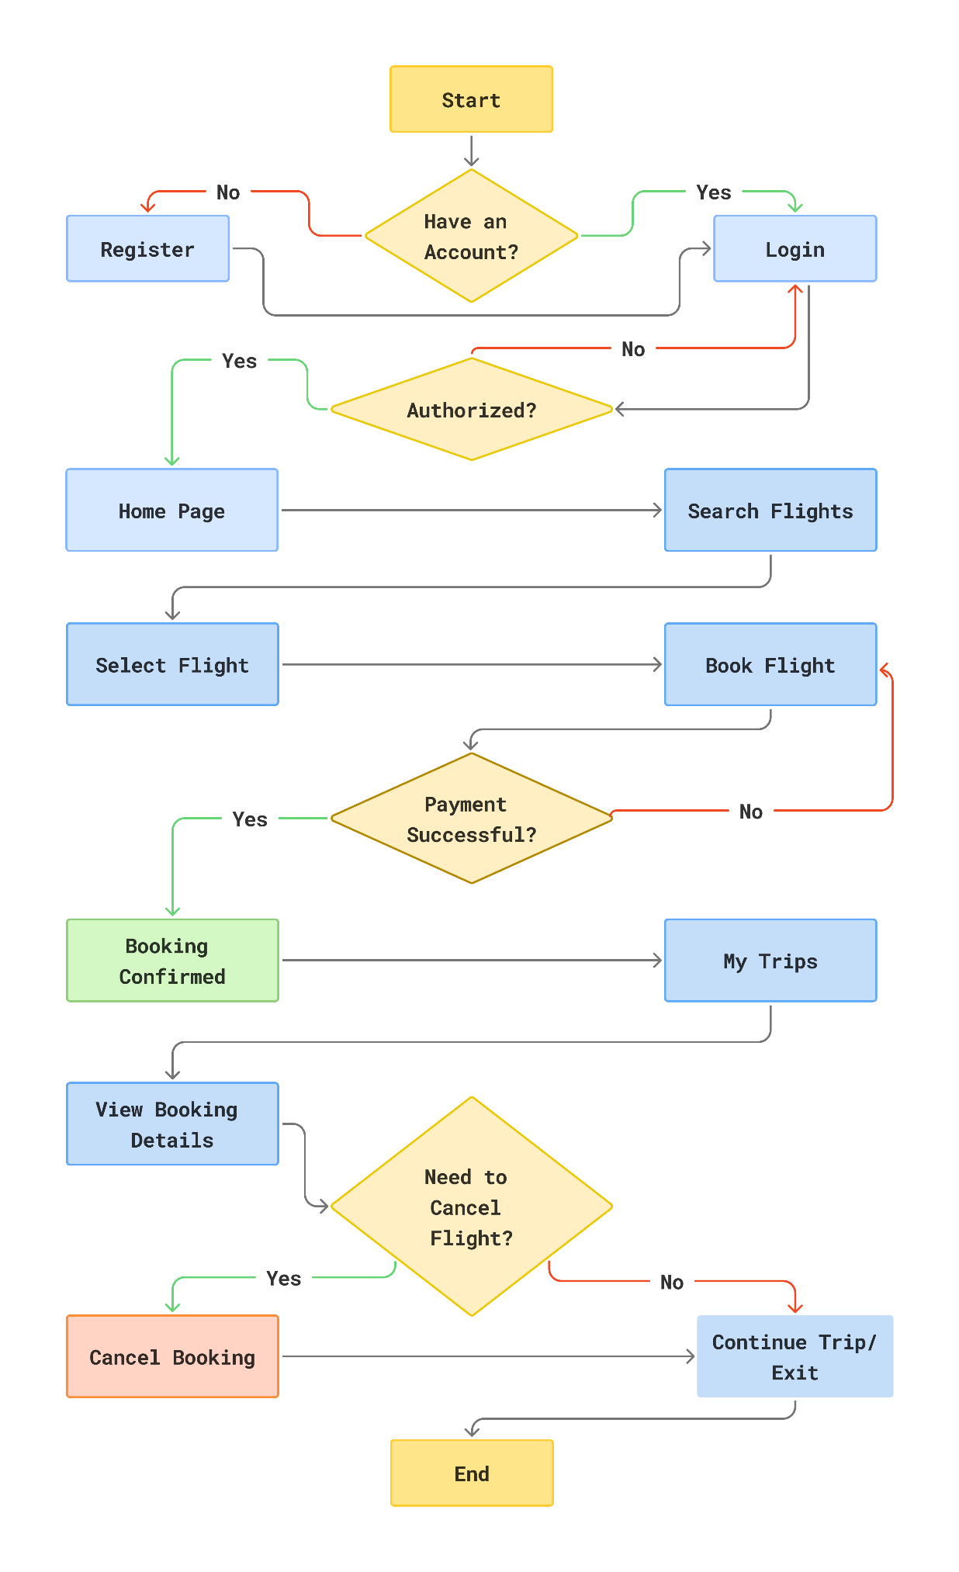

**4. DFD and UML Diagram**

**0 Level Diagram (Context Diagram)**

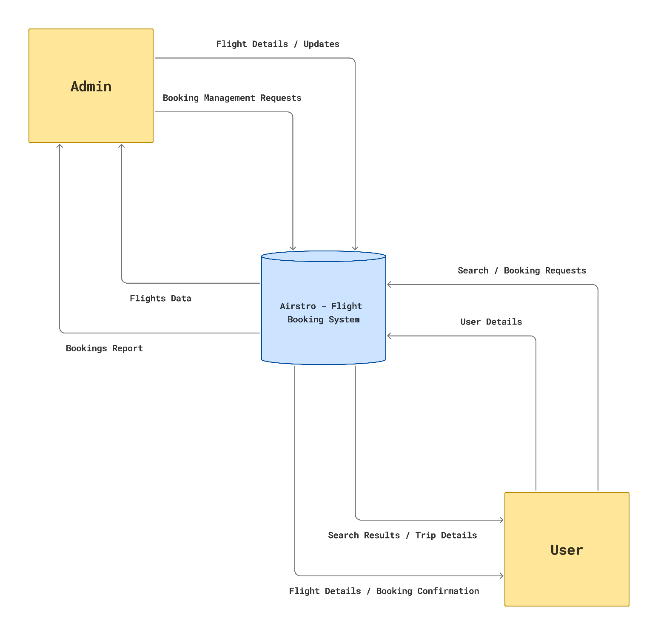

**1 Level Admin Diagram**

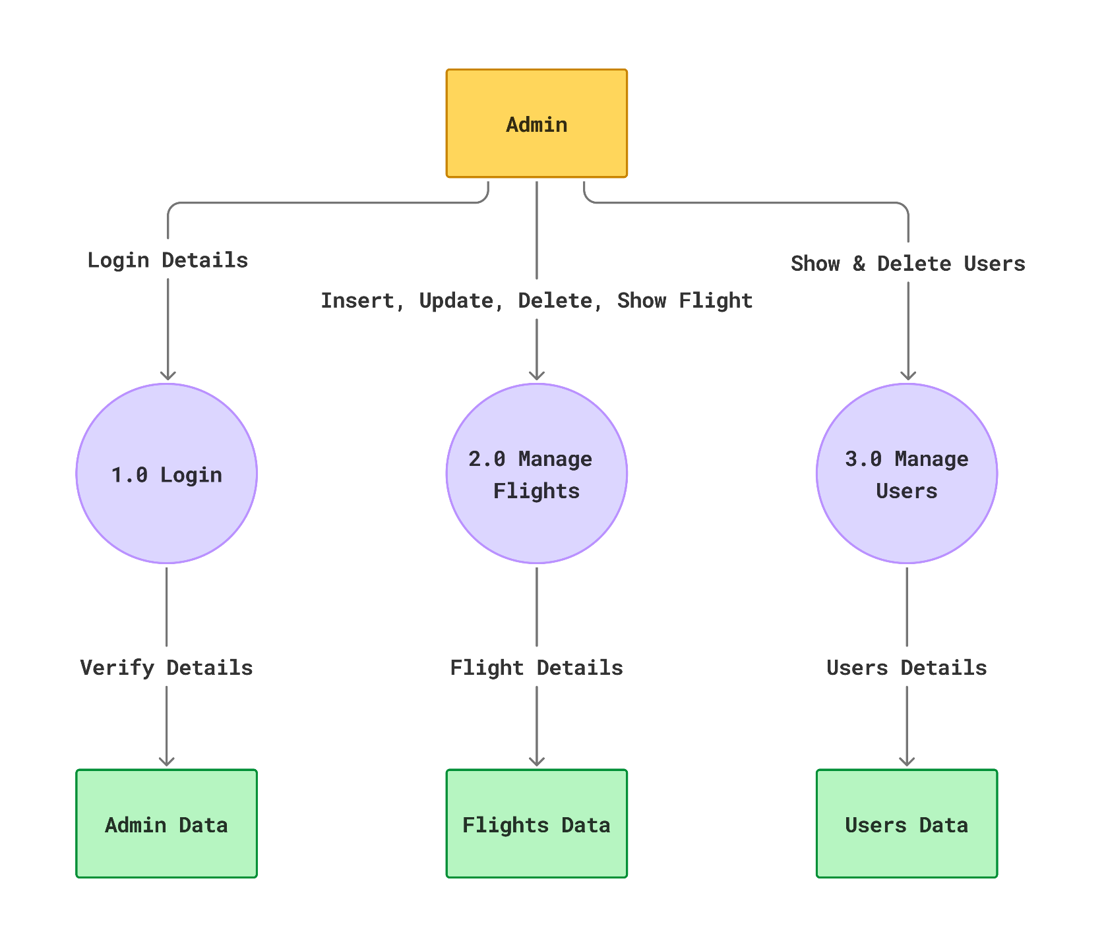

**1 Level User Diagram**

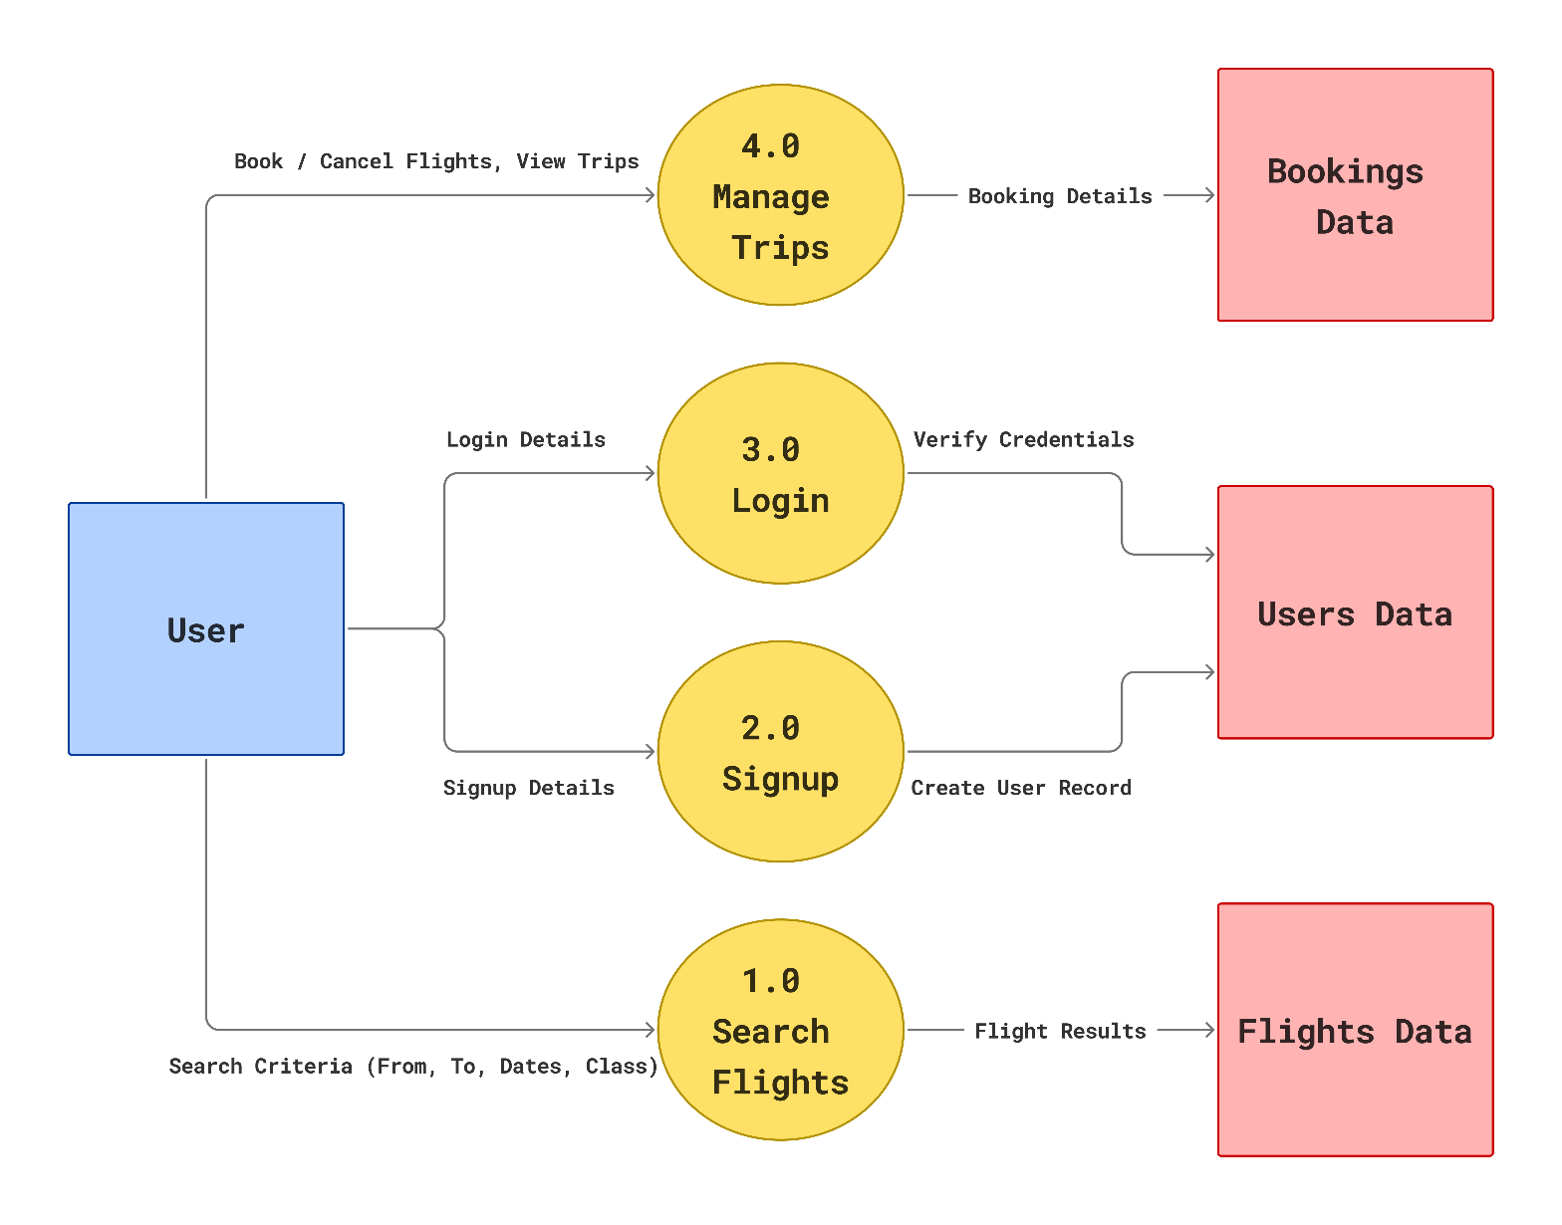

**5. ER Diagram**

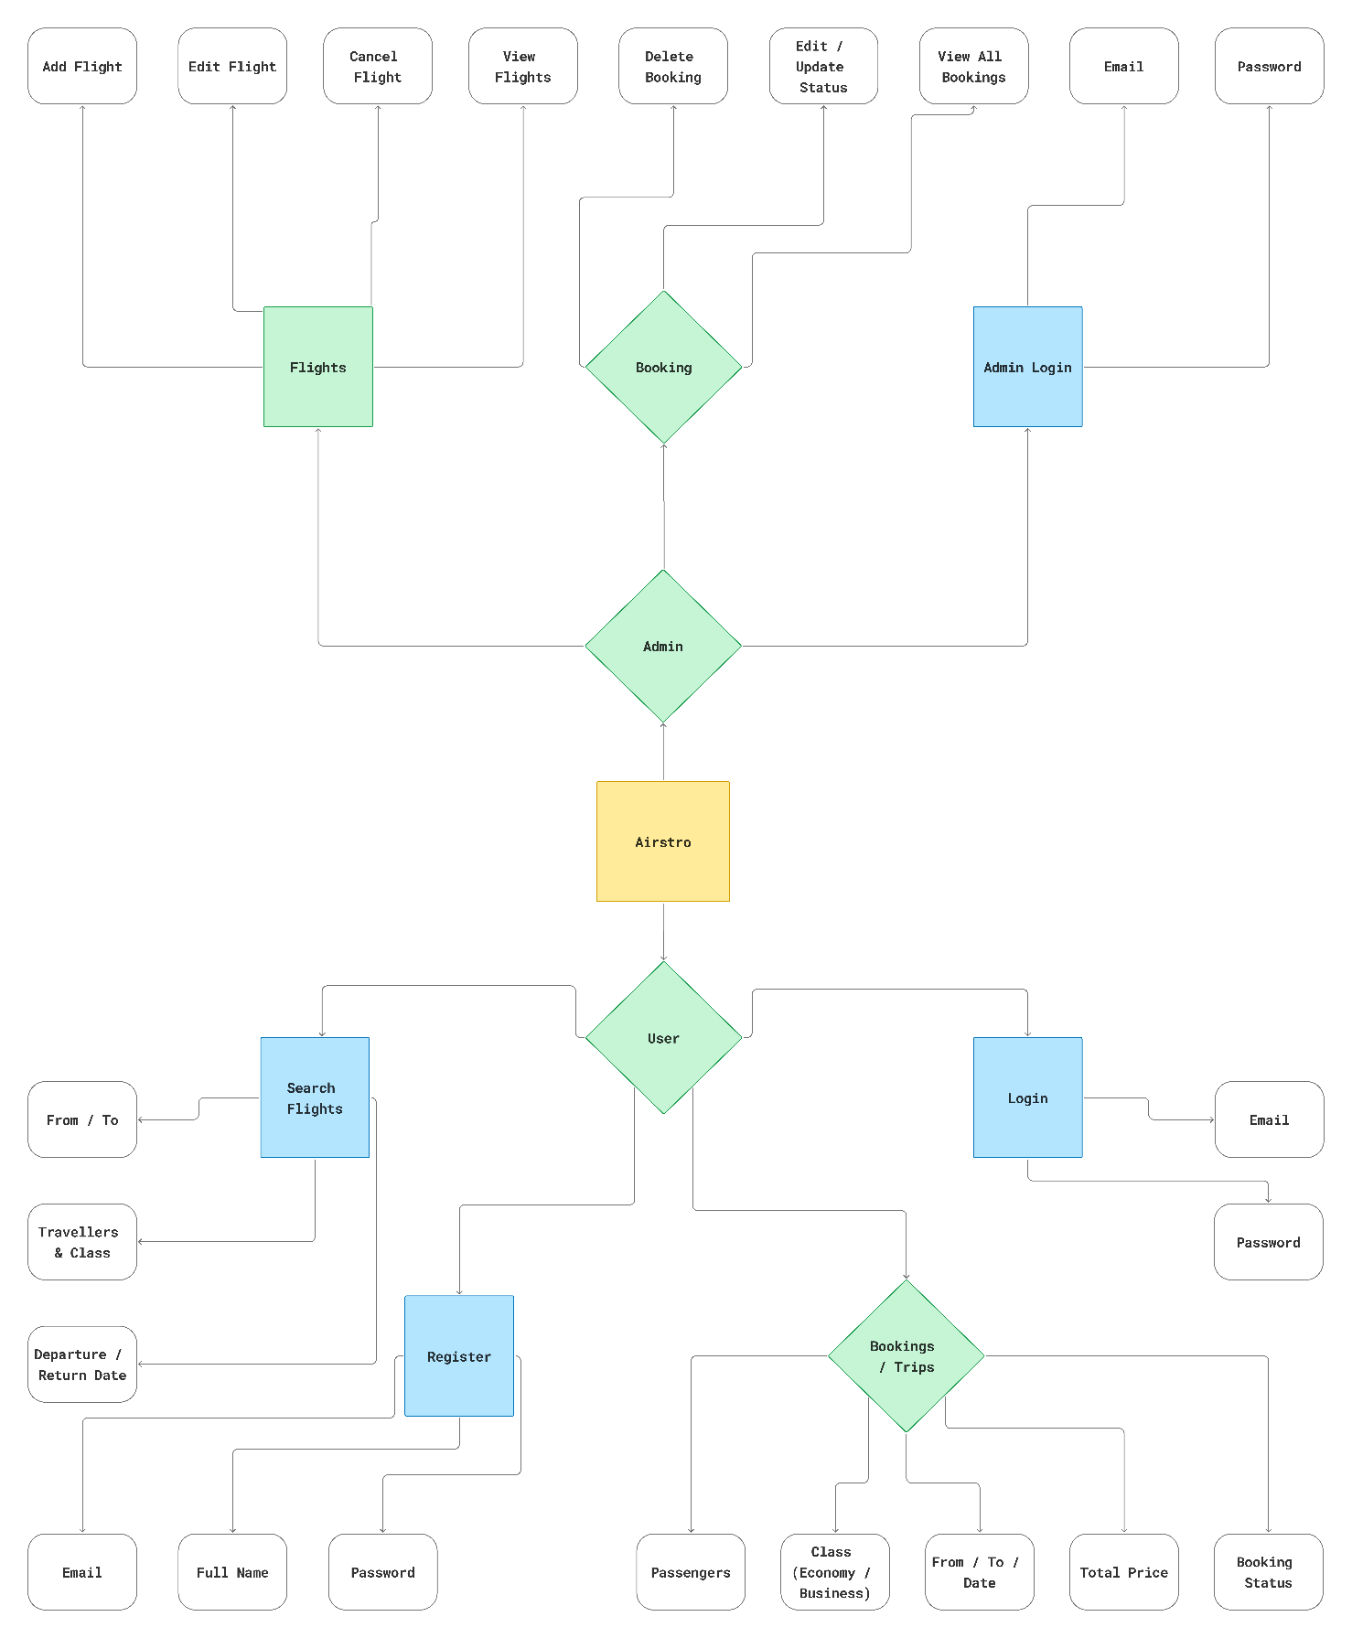

1. **Data Dictionary**

**User / Admin Table**

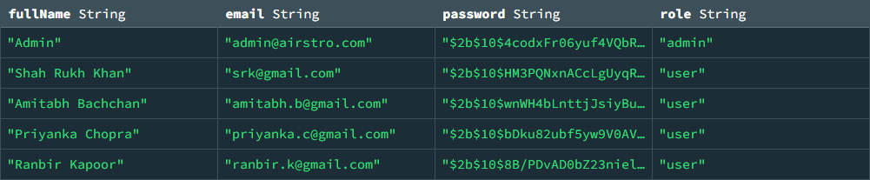

**Flight Table**

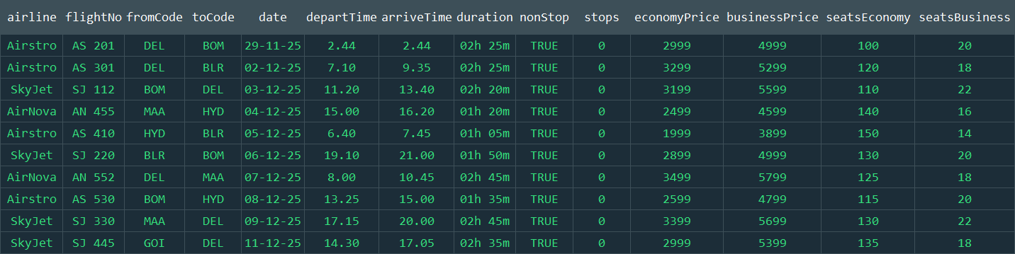

**Bookings Table**

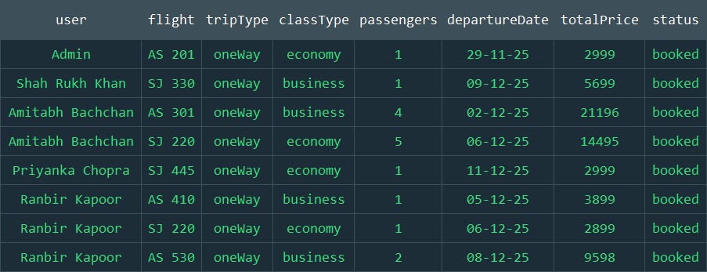

**7. System Design**

**Admin Login**

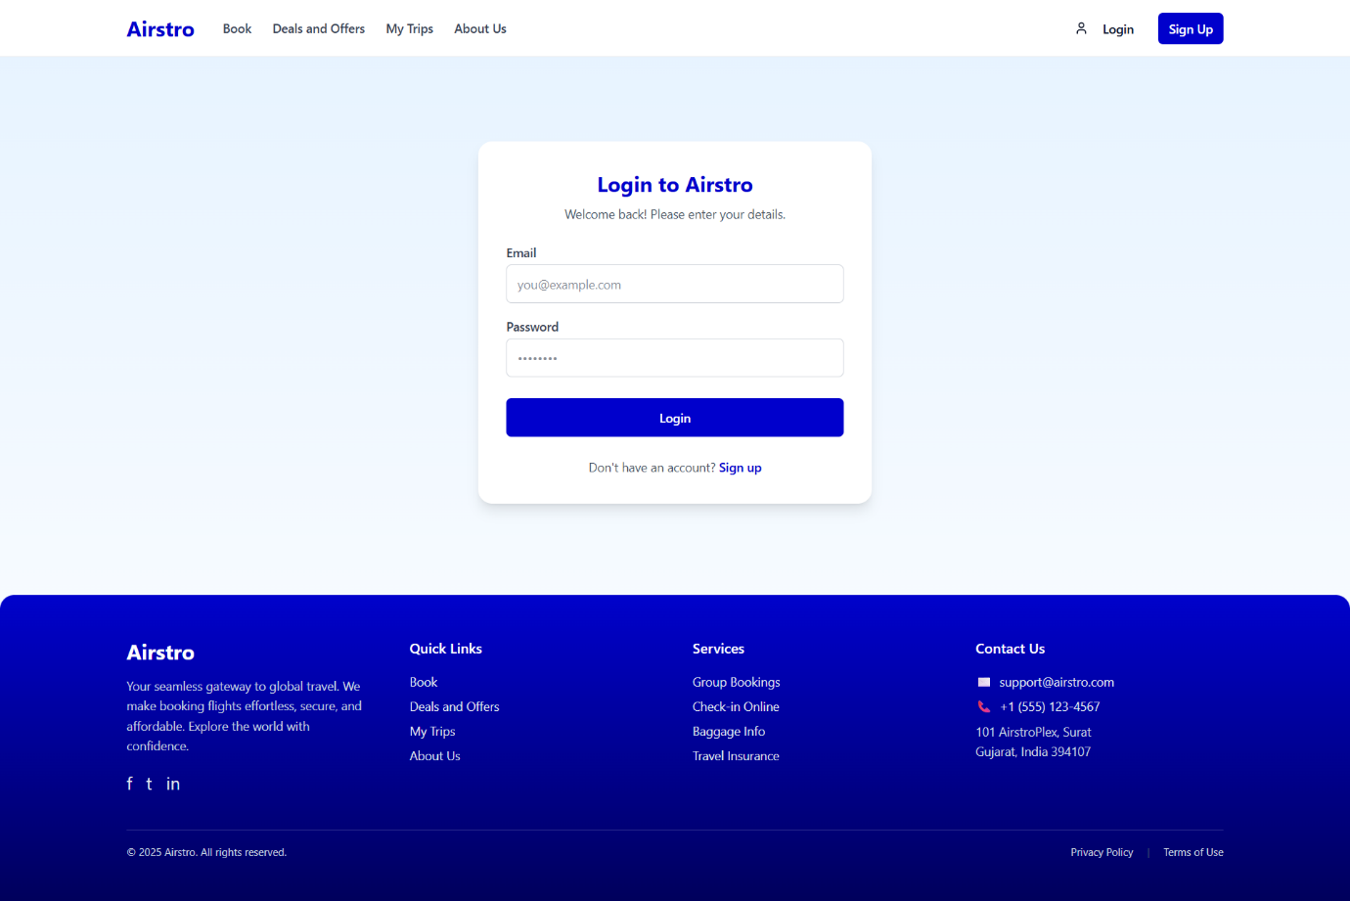

**Admin Dashboard**

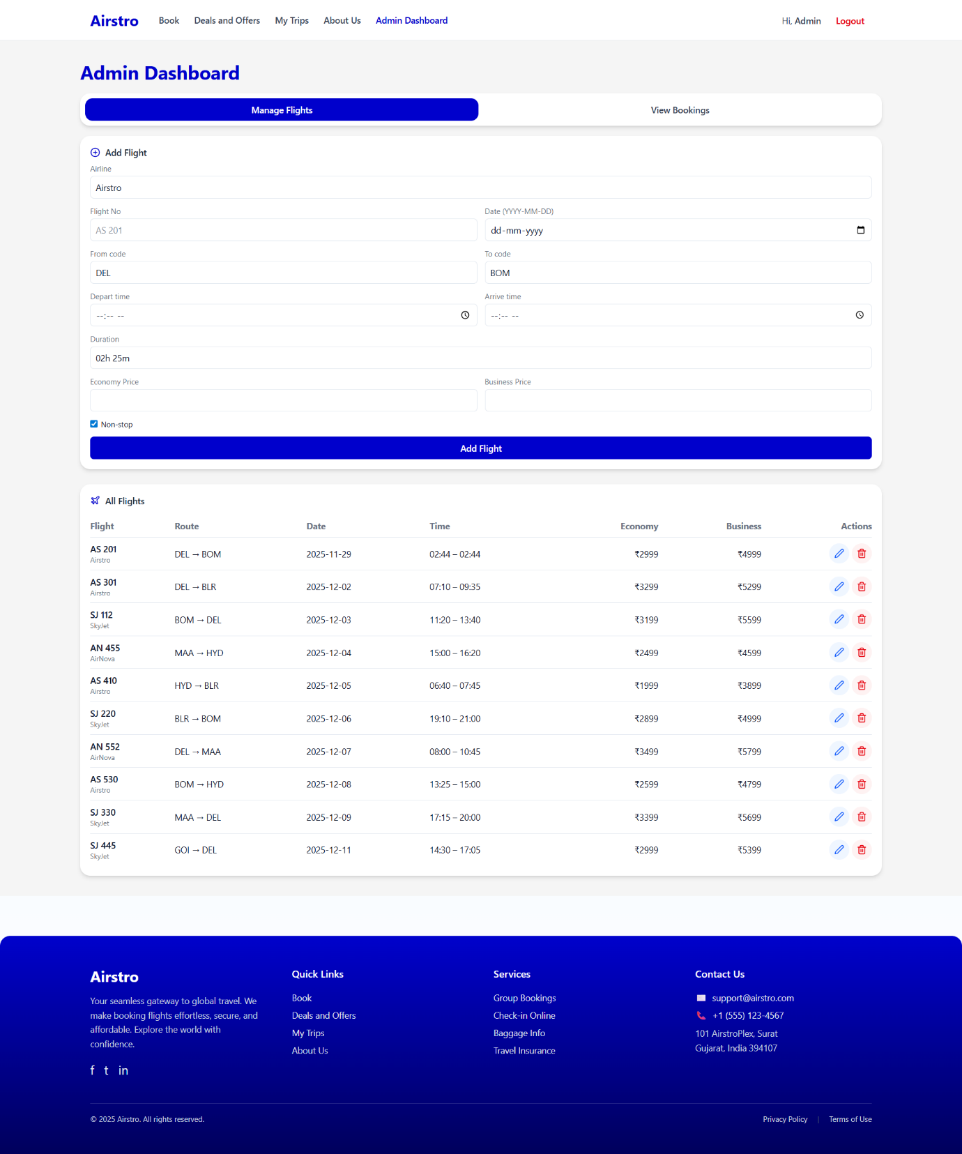

**Admin Dashboard**

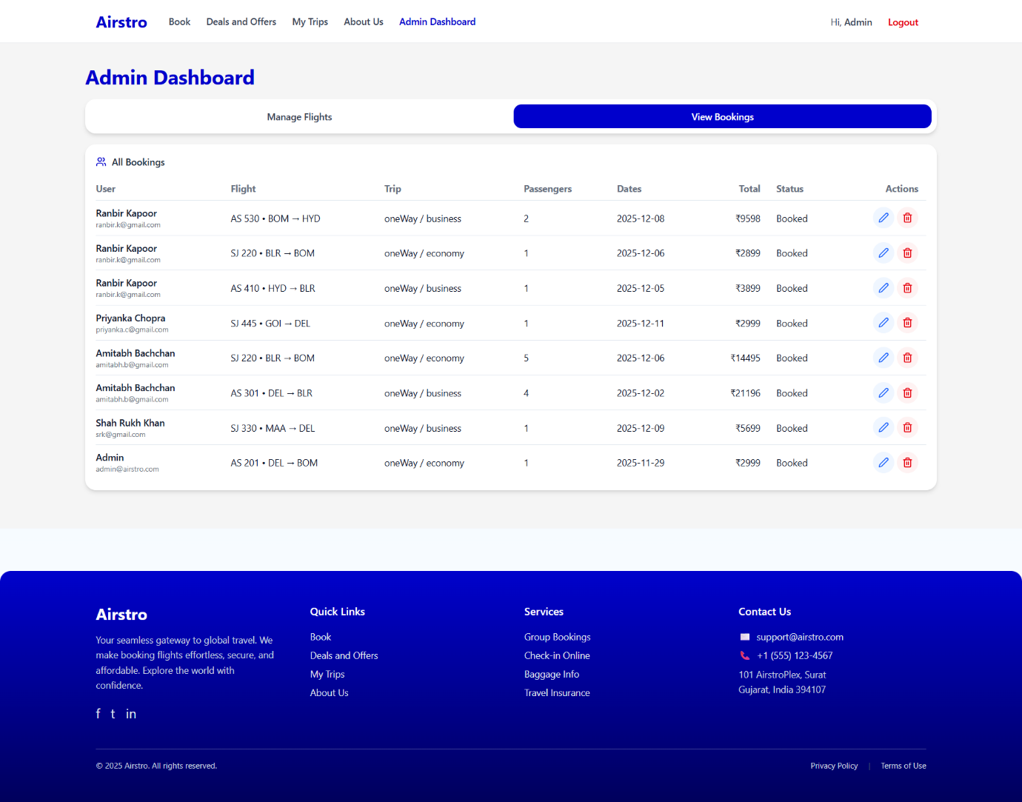

**User Sign Up**

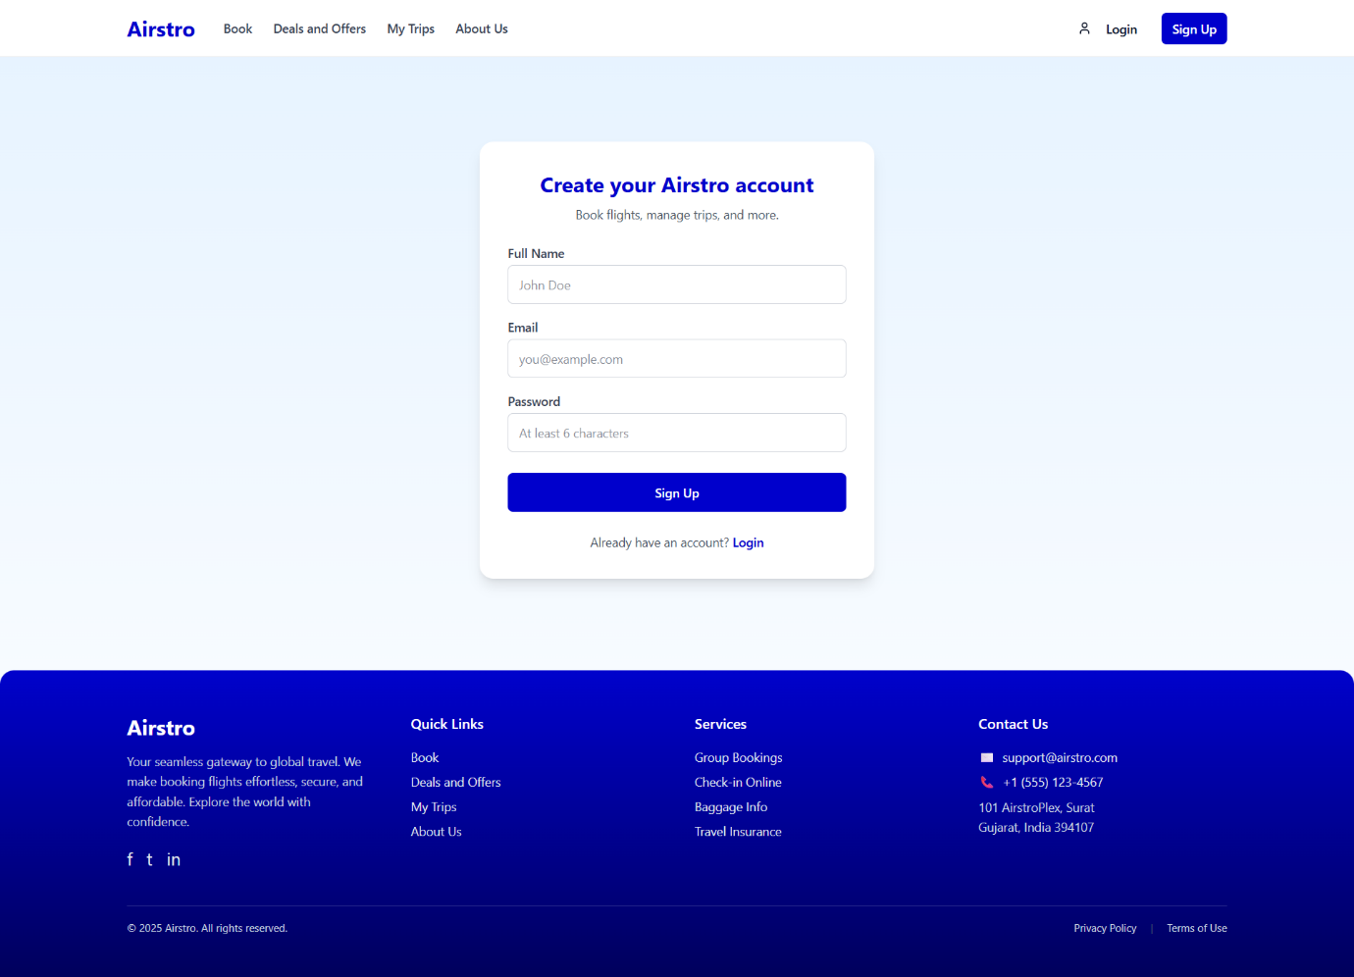

**User Log In**



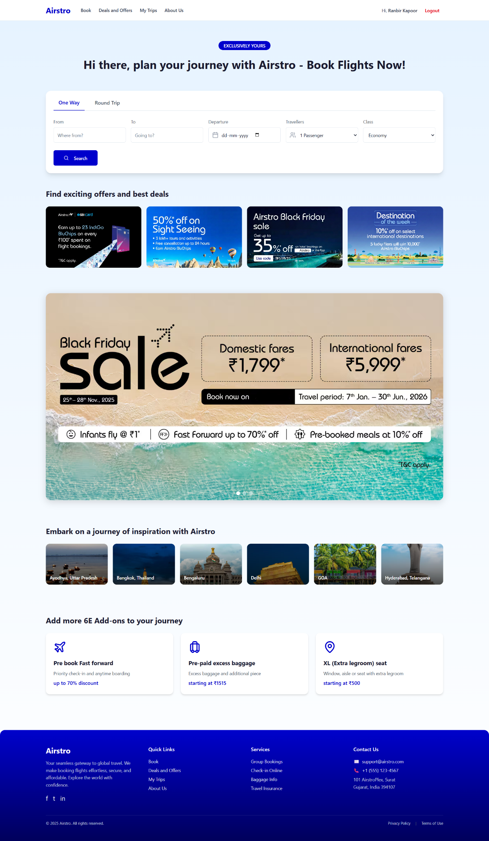**Home Page**

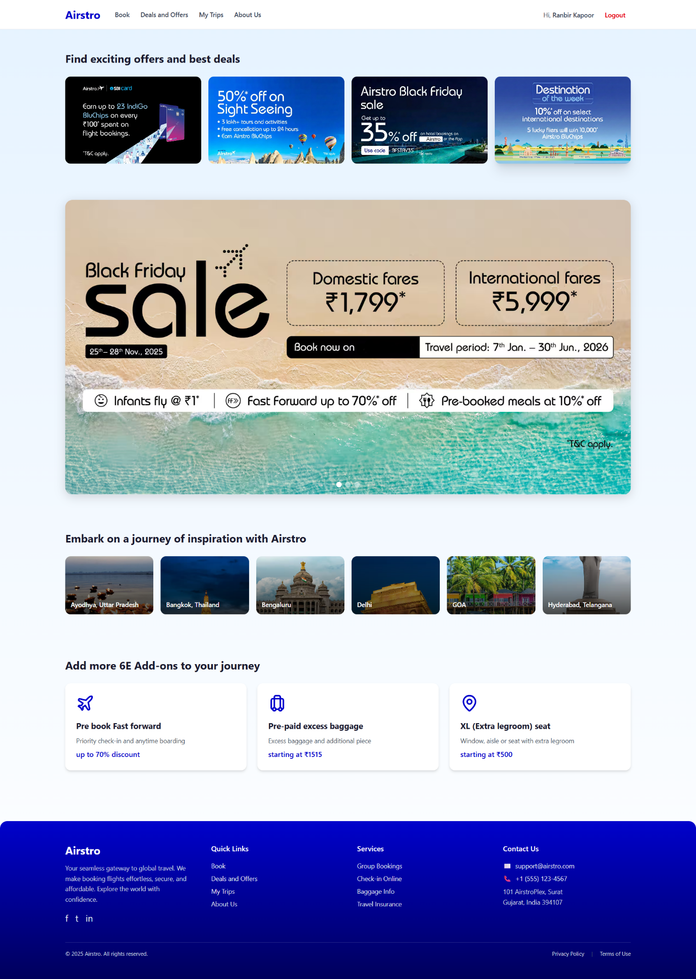**Deals and Offer Page**

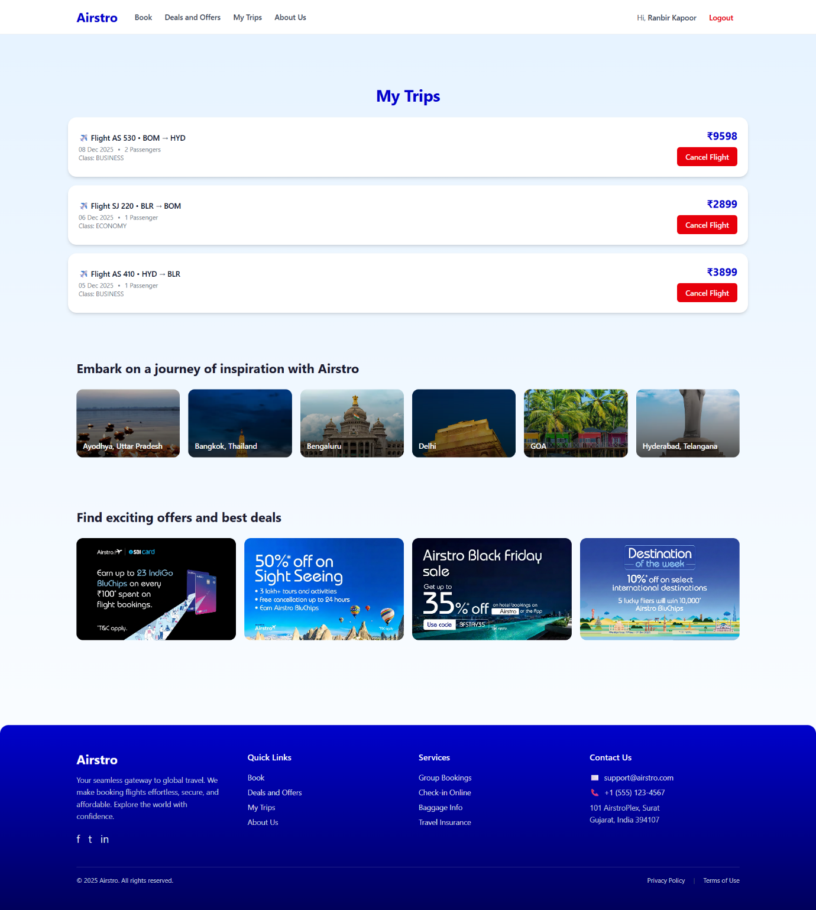**My Trips Page**

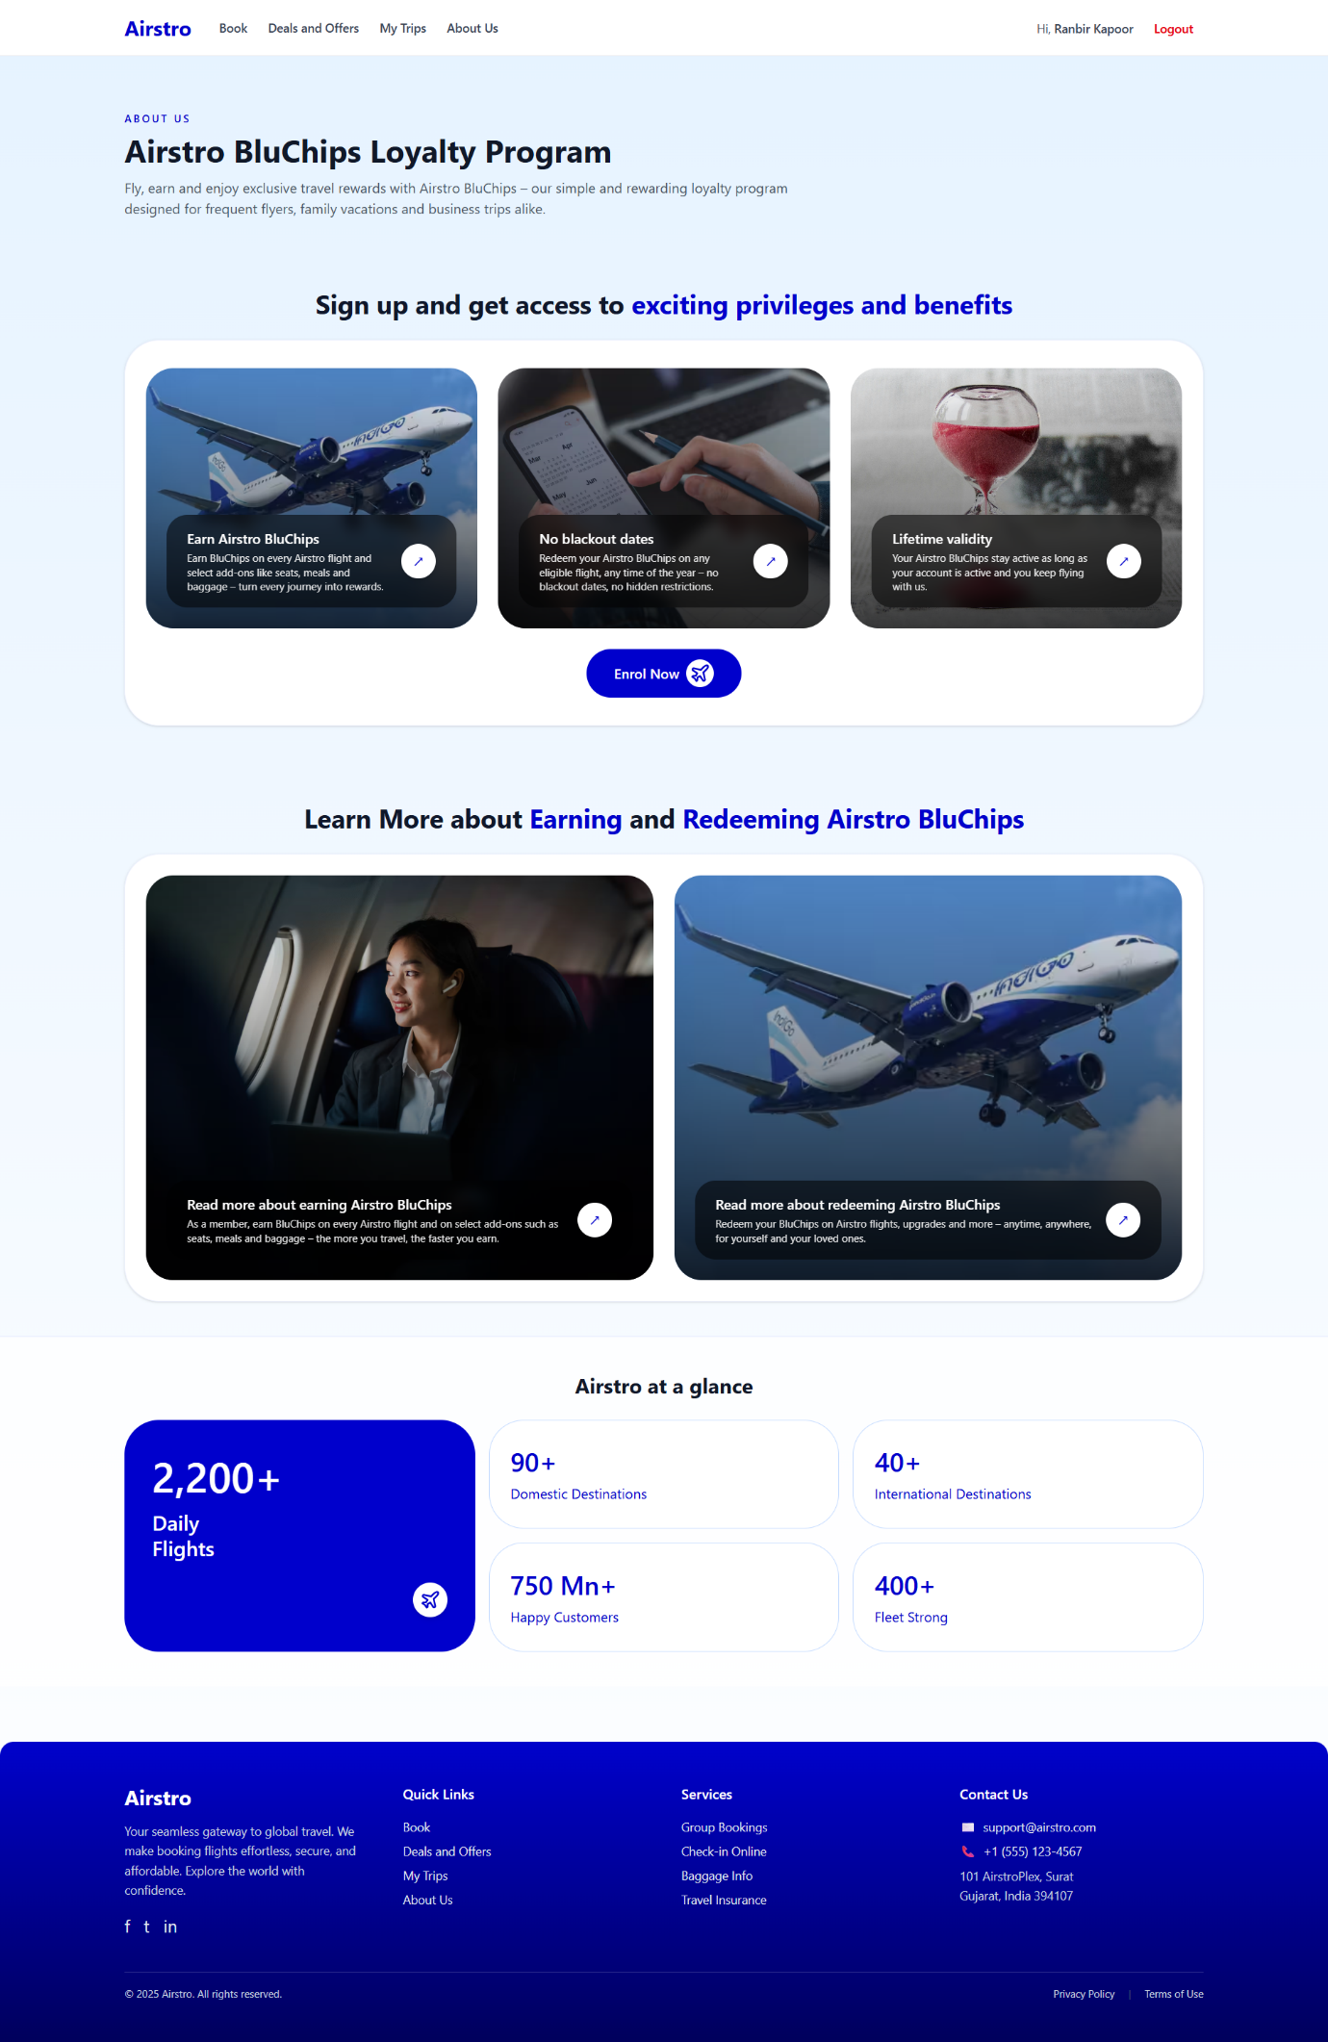**About Us Page**

1. **Conclusion**
   1. **Limitations**

* The system does not include an integrated online payment gateway for ticket purchases.
* Analytics and reporting are limited, so admins cannot generate advanced insights such as most-booked routes, seasonal demand, or revenue reports.
* The platform is not fully optimized for mobile devices, which may reduce convenience for users accessing the system on smartphones.
* The system lacks advanced filtering options (e.g., filtering flights by airline, class type, number of stops, or date range).
* Currently supports only Admin and User roles; there are no separate modules for airline staff, travel agents, or super admin.
* No advanced statistics dashboard is available for admins (e.g., peak travel times, cancellation trends, or flight performance comparison).
  1. **Future Enhancement**
* Develop a mobile application for users and admins to easily book flights, manage bookings, and monitor flight updates.
* Integrate a secure online payment gateway to allow users to make ticket payments through UPI, credit/debit card, and net banking.
* Add AI-based smart price prediction and travel suggestions to recommend the best time to book based on fare trends.
* Introduce additional roles (e.g., Airline Staff, Travel Agent, and Super Admin) with separate privileges and dashboard access.
* Enhance security features such as Two-Factor Authentication (2FA), CAPTCHA verification, and encrypted login sessions.
* Provide advanced analytics and visual dashboards for admins, including booking statistics, revenue trends, route popularity, cancellation charts, and flight performance insights.
  1. **Conclusion**

The Airstro – Online Flight Booking System provides a modern and efficient solution for managing airline bookings digitally. It eliminates the need for traditional offline ticket reservations and offers a user-friendly platform where users can easily search flights, book tickets and manage their bookings. The admin can efficiently maintain flight schedules, update information, and oversee bookings through a centralized dashboard. By implementing digital automation, transparency, and role-based access control, Airstro improves the overall passenger experience and simplifies administrative operations. the system has high potential to evolve into a complete and scalable online airline reservation platform.

1. **Annexures**

**A. Progress Timeline**

* Weeks 1–2: Requirement gathering, planning, and system design (wireframes, ER diagram, DFD, database schema).
* Weeks 3–4: Backend development (Node.js/Express CRUD operations for users, flights, bookings, authentication).
* Weeks 5–6: Frontend development (React.js + TailwindCSS UI components, forms, dashboards, routing).
* Weeks 7–8: Integration (User flight booking workflow, Admin flight management).
* Weeks 9–10: Testing (functional & performance) and deployment.

**B. Technology Reference**

* React.js & TailwindCSS Documentation – Frontend user interface development
* Node.js & Express.js Documentation – Backend API logic and authentication
* MongoDB Documentation – Database schema design and queries
* JavaScript Documentation – Core scripting & component functionalities
* Vite Documentation – Project setup and frontend development server

**C. Testing Results**

* **Functional Testing**
* User registration & login ✓ PASSED
* User flight search and booking ✓ PASSED
* Booking cancellation by user ✓ PASSED
* Admin add/update/delete flights ✓ PASSED
* Admin manage & schedule flights ✓ PASSED
* User view booking history ✓ PASSED
* **Performance Testing**
* Concurrent users supported: 50+ users successfully tested
* Average API response time: 0.45 seconds
* Average database query execution: 0.06 seconds

**D. Deployment Information**

* Platform: Localhost / Cloud-based deployment (Node.js server)
* Database: MongoDB Atlas / Local MongoDB instance
* Monitoring: Backend logs enabled for booking and flight activity tracking

**E. User Guide**

* **For User**

1. Register or Login
2. Search available flights
3. Select seat(s) and book ticket
4. View booking history or cancel bookings

* **For Admin**

1. Login as Admin
2. Add / Update / Delete flight details
3. Schedule or cancel flights
4. Monitor all bookings and users